LED Interfacing

LED is semiconductor device used in many electronic devices, mostly used for signal transmission /power indication purposes. It is very cheaply and easily available in a variety of shape, color, and size. The LEDs are also used for design message display boards and traffic control signal lights etc.

An LED is basically a PN Junction Diode, which emits light when forward biased.

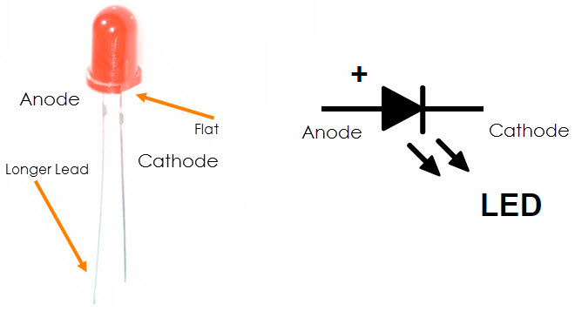

Advantages:
- Low Power Consumption
- Small Size
- Fast Switching
- Physically Robust
- Long Lasting

Applications:
- Cars, Bikes, Street Lights, Home Lighting, Office Lighting, Mobile Phones, Televisions .

LED Interfacing:

There are two ways which we can interface LED to the Microcontroller 8051.

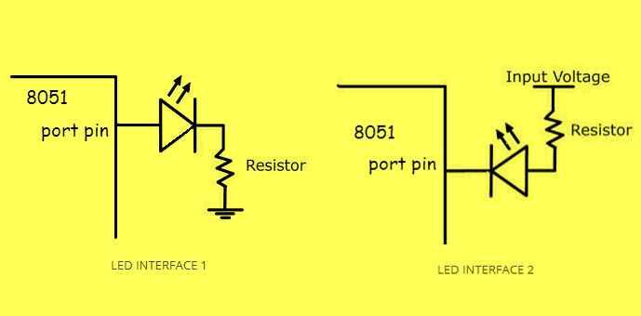
Observe carefully the interface LED 2 is in forward biased because the input voltage of 5v connected to the positive terminal of the LED, So here the Microcontroller pin should be at LOW level. And vice versa with the interface 1 connections.
The resistor is important in LED interfacing to limit the flowing current and avoid damaging the LED and/or MCU.
- Interface 1 will glow LED, only if the PIN value of the MC is HIGH as current flows towards the ground.
- Interface 2 will glow LED, only if the PIN value of the MC is LOW as current flows towards PIN due to its lower potential.

LED interfacing with 89c51

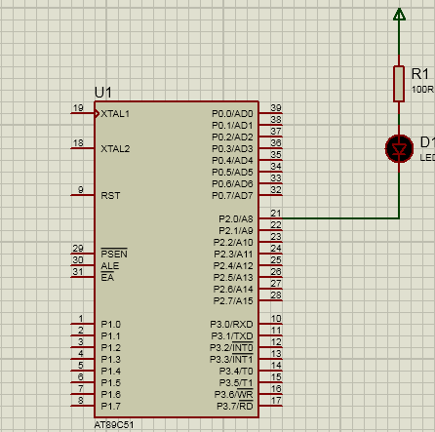

LED and Switch Interfacing

A push-button is a type of momentary switch which when pressed completes a circuit, and when released, the button returns to its original position and breaks or interrupts a circuit.
The switch is an input device. When interfaced with microcontroller, it can be used to control other peripherals connected to the microcontroller. It basically “makes” the electrical circuit by establishing the flow of current. Or “breaks” it by interrupting the flow of current. For a supply voltage of 5V connected to the 8051 microcontrollers, the current drawn when a resistor of 10k is used is 5/10k = 5mA, which is perfect.

Positive Logic
When the resistor is connected to the ground, it is called a pull-down resistor.
- When the switch is OFF (not pressed), the input to port pin is a LOW pulse (0).
- When the switch is ON (pressed), the input to port pin is a HIGH pulse (1).
Negative Logic
- When the resistor is connected to the VCC, it is called a pull-up resistor.
- When the switch is OFF (not pressed), the input to port pin is a HIGH pulse (1).
- When the switch is ON (pressed), the input to port pin is a LOW pulse (0).
Interfacing With 89c51
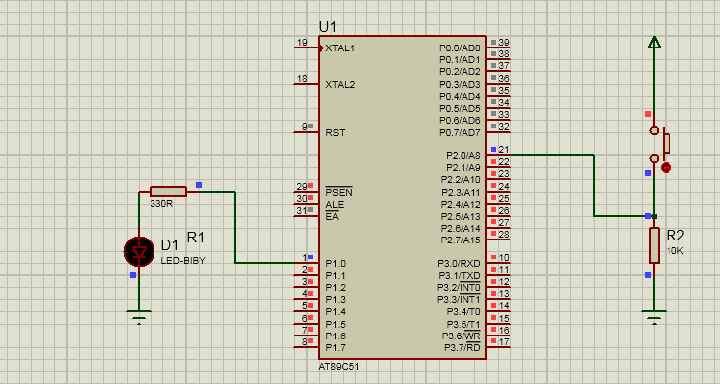

Seven Segment Display Interfacing
The 7-segment display, consists of seven LEDs (hence its name) arranged in a rectangular fashion as shown. Each of the seven LEDs is called a segment because when illuminated the segment forms part of a numerical digit (both Decimal and Hex) to be displayed.
An additional 8th LED is sometimes used within the same package thus allowing the indication of a decimal point, (DP) when two or more 7-segment displays are connected together to display numbers greater than ten.
Each one of the seven LEDs in the display is given a positional segment with one of its connection pins being brought straight out of the rectangular plastic package. These individually LED pins are labelled from a through to g representing each individual LED. The other LED pins are connected together and wired to form a common pin.
So by forward biasing the appropriate pins of the LED segments in a particular order, some segments will be light and others will be dark allowing the desired character pattern of the number to be generated on the display. This then allows us to display each of the ten decimal digits 0 through to 9 on the same 7-segment display.
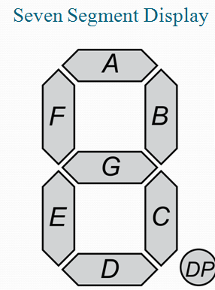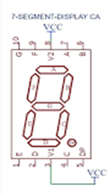
The displays common pin is generally used to identify which type of 7-segment display it is. As each LED has two connecting pins, one called the “Anode” and the other called the “Cathode”, there are therefore two types of LED 7-segment display called: Common Cathode (CC) and Common Anode (CA).
The difference between the two displays, as their name suggests, is that the common cathode has all the cathodes of the 7-segments connected directly together and the common anode has all the anodes of the 7-segments connected together and is illuminated as follows.
1. The Common Cathode (CC) – In the common cathode display, all the cathode connections of the LED segments are joined together to logic “0” or ground. The individual segments are illuminated by application of a “HIGH”, or logic “1” signal via a current limiting resistor to forward bias the individual Anode terminals (a-g).

Common Cathode Configuration

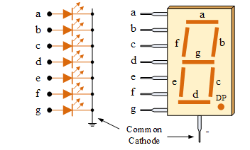

2. The Common Anode (CA) – In the common anode display, all the anode connections of the LED segments are joined together to logic “1”. The individual segments are illuminated by applying a ground, logic “0” or “LOW” signal via a suitable current limiting resistor to the Cathode of the particular segment (a-g).

Common Anode Configuration
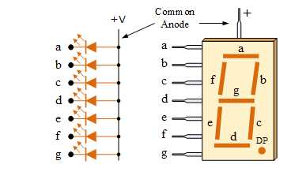
In general, common anode displays are more popular as many logic circuits can sink more current than they can source. Also note that a common cathode display is not a direct replacement in a circuit for a common anode display and vice versa, as it is the same as connecting the LEDs in reverse, and hence light emission will not take place.
Depending upon the decimal digit to be displayed, the particular set of LEDs is forward biased. For instance, to display the numerical digit 0, we will need to light up six of the LED segments corresponding to a, b, c, d, e and f. Thus the various digits from 0 through 9 can be displayed using a 7-segment display as shown.

Digital Segments for all Numbers
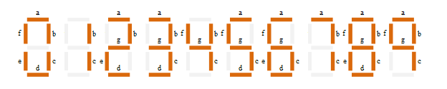
Then for a 7-segment display, we can produce a truth table giving the individual segments that need to be illuminated in order to produce the required decimal digit from 0 through 9 as shown below.
Table shows hex codes for common anode display.

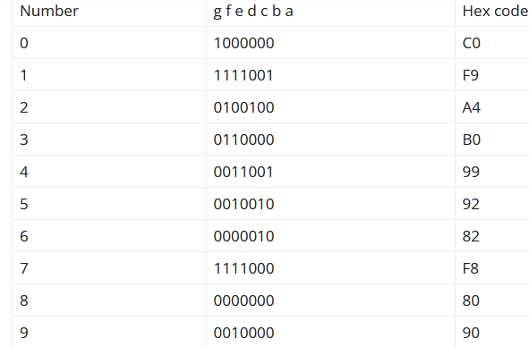

Hex codes for common cathode display

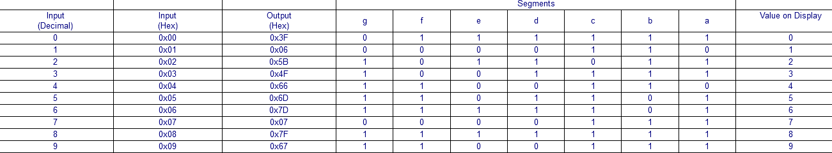

Interfacing seven segment display with 89c51

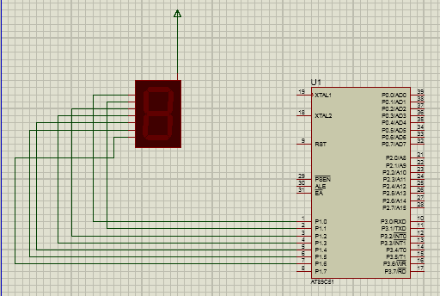

Seven Segment display multiplexing

By multiplexing seven-segment displays the number of pins required to drive the displays can be reduced.
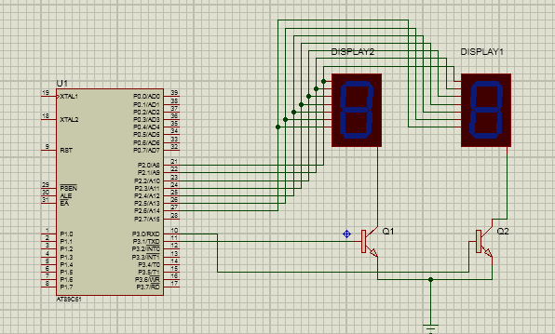

LCD interfacing with 8051 Microcontroller

LCD DISPLAY
We always use devices made up of Liquid Crystal Displays (LCDs) like computers, digital watches.
Here we are using alphanumeric LCD 16×2. A 16×2 LCD display is a very basic module and is very commonly used in various devices and circuits. These modules are preferred over seven segments and other multi-segment LEDs. The reasons being: LCDs are economical; easily programmable; have no limitation of displaying special & even custom characters (unlike in seven segments).
A 16×2 LCD means it can display 16 characters per line and there are 2 such lines. In this LCD each character is displayed in a 5×7 pixel matrix. This LCD has two registers, namely, Command and Data. The command register stores the command instructions given to the LCD. A command is an instruction given to LCD to do a predefined task like initializing it, clearing its screen, setting the cursor position, controlling display, etc. The data register stores the data to be displayed on the LCD. The data is the ASCII value of the character to be displayed on the LCD.

Pin Diagram
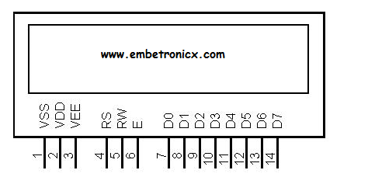

Pin No | Function |  | Name
1 | Ground (0V) |  | Ground
2 | Supply voltage; 5V (4.7V – 5.3V) |  | Vcc
3 | Contrast adjustment; through a variable resistor |  | V_{EE}
4 | Selects command register when low; and data register when high |  | Register Select
5 | Low to write to the register; High to read from the register |  | Read/write
6 | Sends data to data pins when a high to low pulse is given |  | Enable
7 | 8-bit data pins |  | DB0
8 |  |  | DB1
9 |  | DB2
10 |  | DB3
11 |  | DB4
12 |  | DB5
13 |  | DB6
14 |  | DB7

The LCD display module requires 3 control lines as well as either 4 or 8 I/O lines for the data bus. The user may select whether the LCD is to operate with a 4-bit data bus(4bit mode) or an 8-bit data bus (8 bit mode).
If a 4-bit data bus is used the LCD will require a total of 7 data lines (3 control lines plus the 4 lines for the data bus). If an 8-bit data bus is used the LCD will require a total of 11 data lines (3 control lines plus the 8 lines for the data bus).
The three control lines are referred to as EN, RS, and RW.
The EN line is called “Enable.” It is used to by the LCD to latch information presented to its data pins. When data is supplied to data pins ,high to low pulse must be applied to this pin to latch data .This pulse must be minimum of 450ns wide.
The RS line is the “Register Select” line. When RS is low (0), instruction command code register is selected ,allowing the user to send the command (such as clear screen, position cursor, etc.). When RS is high (1), the data register is selected ,allowing the user to to send data displayed on LCD.
The R/W line is the “Read/Write” control line. When RW is low (0), the information on the data bus is being written to the LCD. When RW is high (1), the program is effectively querying (or reading) the LCD. Only one instruction (“Get LCD status”) is a read command. All others are write commands–so RW will almost always be LOW.
Finally, the data bus consists of 4 or 8 lines (depending on the mode of operation selected by the user). In the case of an 8-bit data bus, the lines are referred to as DB0, DB1, DB2, DB3, DB4, DB5, DB6, and DB7.

LCD COMMANDS
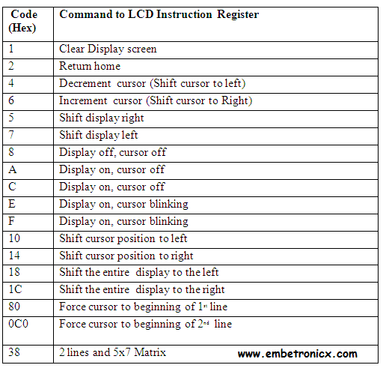
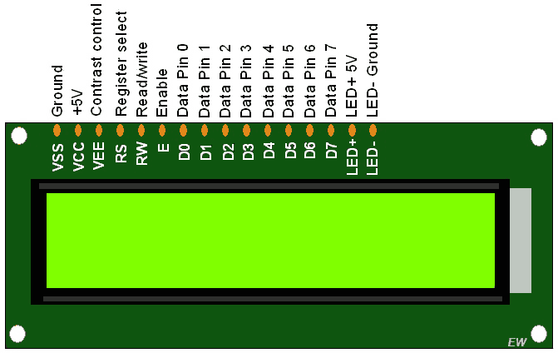

LCD interfacing with Microcontrollers tutorial - Checking busy flag
Reading the busy Flag
As discussed in the previous section, there must be some delay which is needed to be there for LCD to successfully process the command or data. So this delay can be made either with a delay loop of specified time more than that of LCD process time or we can read the busy flag, which is recommended. The reason to use busy flag is that delay produced is almost for the exact amount of time for which LCD need to process the time. So is best suited for every application.
Steps to read busy flag
When we send the command, the BF or D7th bit of the LCD becomes 1 and as soon as the command is processed the BF = 0. Following are the steps to be kept in mind while reading the Busy flag.
- Select command register
- Select read operation
- Send enable signal
- Read the flag

- How to generate LCD Custom Character using 8051

Introduction
So we know how to display alphanumeric characters in LCD. We can easily display that. Because it is already stored in the ROM memory of LCD. Before that we should know the memories of LCD. There are three types of memory present in the LCD display.
- CG ROM
- DD RAM
- CG RAM

CG ROM (Character Generator ROM)
This memory holds the pattern for every single character of predefined LCD font. and you call the content of this memory by the placing corresponding ASCII value on the LCD port . For example if you want to display ‘A’ you have to send the ASCII value of ‘A’ which is 0x41 to the LCD. So we cannot modify its contents which is stored already.

DD RAM (Display Data RAM)
DDRAM is the memory which holds only those characters which are currently on the screen . means if there is a message is currently being displayed on the screen then it has to be on the DDRAM. For example if you want to display “hello” on the screen then you have to load pattern of h from the CG ROM to DD RAM then do the same for ‘e’ ,’l’ ,’l’ and ‘o’.
This is the address of the DDRAM memory in 16×2 LCD
Position | 1 | 2 | 3 | 4 | ..... | 16
Row1 | 0x80 | 0X81 | 0X82 | 0X83 | ...... | 0X8F
Row2 | 0xC0 | 0XC1 | 0XC2 | 0XC3 | ...... | 0XCF
This memory works same as CG ROM but as this is RAM we can modify it’s content any time. So this is the place where we can store our custom character pattern. Then that pattern can be sent to display.

CG RAM (Character generator RAM)
For making custom patterns we need to write values to the CGRAM area defining which pixel to glow. These values are to be written in the CGRAM address starting from 0x40. Bit 7 is 0 and Bit 6 is 1, due to which the CGRAM address command starts from 0x40, where the address of CGRAM starts from 0x00. CGRAM has a total of 64 Bytes. When you are using LCD as 5×8 dots in function set then you can define a total of 8 user defined patterns (1 Byte for each row and 8 rows for each pattern), where as when LCD is working in 5×10 dots, you can define 4 user defined patterns.

Interfacing LCD in 8 bit mode
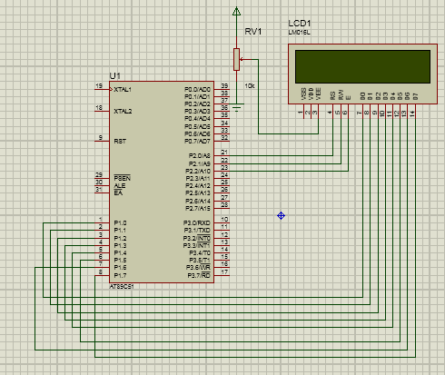

Interfacing LCD in 4 bit mode
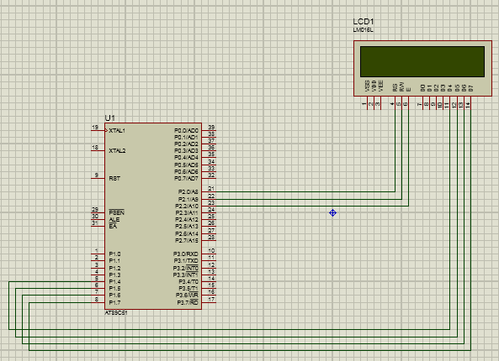

4*4 Matrix Keypad
Keypads are widely used input devices being used in various electronics and embedded projects. They are used to take inputs in the form of numbers and alphabets, and feed the same into system for further processing. In this tutorial we are going to interface a 4x4 matrix keypad with 8051 microcontroller.
Before we interface the keypad with microcontroller, first we need to understand how it works. Matrix keypad consists of set of Push buttons, which are interconnected. Like in our case we are using 4X4 matrix keypad, in which there are 4 push buttons in each of four rows. And the terminals of the push buttons are connected according to diagram. In first row, one terminal of all the 4 push buttons are connected together and another terminal of 4 push buttons are representing each of 4 columns, same goes for each row. So we are getting 8 terminals to connect with a microcontroller.
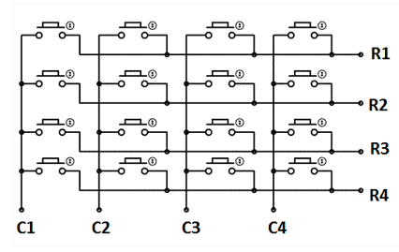
To get the location of the pressed button follow below steps
1)Starting from the top row, the microcontroller will ground it by providing a low to row R1 only.
2)Now read the columns, if the data read is all 1s, no key in that row is pressed and the process continues for the next row.
So, now ground the next row, R2. Read the columns, check for any zero and this process continues till last row 4.
.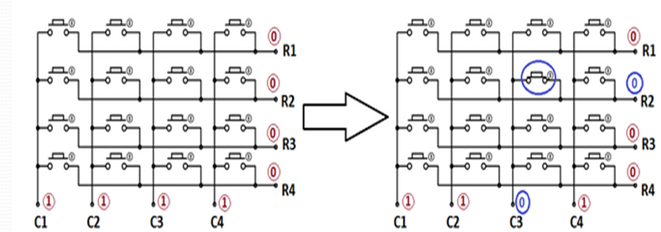

Interfacing Diagram


